Object Classifying Robot

Submitted by
Name: - Shakti Singh

Object Classifying Robot
Shakti Singh Rathore
School of Computer Science and Engineering
Lovely Professional University
Jalandhar, Punjab (India)
shaktisr1968@gmail.com
shakti.11710616@lpu.co.in

ABSTRACT
Robotics is an upcoming and growing branch of Computer Science and Engineering which is surly the dominating field in nearby years. It is well supported by Artificial Intelligence and Machine Learning. These two are the strongest pillars of robotics. It is the known and unknown connection of perception to action. It is the only path which can lead us to an advance and better world.
This research provides a robot which helps itsl users to identify the type, colour, and condition of the fruit or vegetable he is going to buy for himself or others. It is a small mobile or stationary robot which can be placed in fruit or vegetable markets to serve their customers.
Now a day’s services demands high accuracy and performance in their products. Image classification is one of the best road on which we can sort different objects at human level.
.

KEYWORDS
Camera, MATLAB, image comparison, image training, Robotic hand etc.

INTRODUCTION
The robot which we are discussing in this term paper is a highly trained and advanced robot. It will be a very needy robot in the upcoming days in the malls and markets. This is not a complex robot. This robot comprises mainly of two parts camera which will be used to identify the object and robotic hand which will obviously be used to manipulate the objects. First let's discuss about the camera.

CAMERA
In any robot, camera is used to identify and recognise the objects based on training. We will be using a normal camera or a mobile camera which is easily available. Camera is wonderful discovery which intent is used to capture the images and memories worth remembering. It reincarnates our nostalgia.
PROVIDING VISION TO A ROBOT
Robot vision makes robots have visual perception.[1] Robot vision may be defined as the process of extracting, characterizing, and interpreting information from images of a three-dimensional world. This process, also known to as machine or computer vision.
A robot vision system is consists of one or more cameras, software and a robot to manipulate the objects. The camera takes a picture of the object for features that let robot to determine the properties and condition of the object. The intelligent robot vision generates information that is sent to the robot controller and the programmed positions are updated and according to the need the robot will manipulate the object. Depending upon the position of the objects and the length of the robotic arm, the camera might be mounted on the robot or could be in a fixed position within the cell. Calibration is usually needed to relate the vision system coordinate space with the robot. [2]
Many application only need X and Y axis information including rotation which is easily calculated from the image. Sometimes, it is important to have height information too.
For example in shop if robot is setting up the things at their right places on different tracks at different heights when picking up the parts from a bin. We can also get height information by using stereo cameras. However in many cases laser triangulation or parts eyes are the best option in laser triangulation height is derived from the line position projected onto the target surface and viewed from an angle by a camera. One limitation to this is that either the part of the laser line must move. Alternatively when the part size is known camera distance can be determined by the parts experience in size. This technique is common in vision guided d-palletizing. As a best in class solution f a robot vision system is able to navigate many of these complexities and more - providing major advance in automation productivity.
PERSPECTIVE TRANSFORMATIONS
A perspective transformation (also known as imaging transformation) projects 3D points onto a plane. Perspective transformations plays the main role in image processing because they provide an approximation to the manner in which an image is formed by displaying a three-dimensional world.
A model of the image formation process is shown in Fig.1.

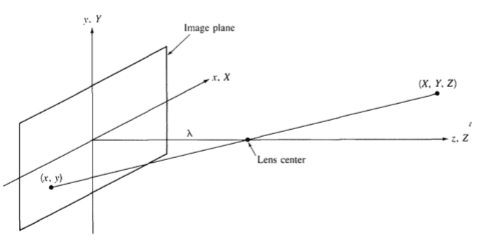
Fig. The camera coordinate system (x ,y ,z) is aligned with the world coordinate system (X, Y, Z).
Thus, the center of the image plane is at the origin, and the center of the lens is at coordinates (0, 0, µ). If the camera is in focus for distant objects, µ is the focal length of the lens.

IBM Watson
IBM Watson is a supercomputer and software provided by the Multinational Company IBM. This software provides different platforms for different tasks. Like it provides cloud platform, machine learning platform, AI platform and much more. We will be using IBM Watson Visual Recognition (VR) platform for upload and classification of images and their training. IBM Watson Visual Recognition is a service that uses deep learning algorithms to identify objects, faces and other contents in an image. For this we will be requiring IBM Cloud and provisioning an instance for Watson Visual Recognition service.
The IBM Watson Visual Recognition service is a powerful AI tool that recognizes image content. The services have the following pretrained models however can also be customized to recognize custom classes.
- General: Trained models that provide you to use active and large data set to gain insights from the pictures provided.
- Food: As same as to the general model, however this model uses a specific food data set. We can use the model to find any type of food and its main applications are in the catering and restaurant industry, especially if you want to create a specific menu.
- Explicit: Allows us to analyze whether the image provided contains inappropriate content or not.
- Text: Allows us to extract text from the provided image and have a textual metadata. This service is currently in private beta.
- Custom: Lets us create a custom model with our provided pictures and train it to get better results for our personal use.

We are using IBM Watson Services because it provides in-build Models for Watson Visual Recognition. After creating our project on this platform, at last we will land on the page where we can create our own “Custom” models to classify objects.
To use IBM Watson for personal use we will be requiring the API key for Watson Visual Recognition API. Watson Visual Recognition services are called “Watson-Vision-Combined-dsx ”
A common way to use Visual Recognition is by accessing the Visual Recognition APIs from any application. The Watson team releases SDKs that support many programming languages so that one can use Visual Recognition easily in a web or mobile application.
One of the most common way of using Watson Visual Recognition is using it as an mobile app. If creating a non-iOS app, the premise is the same, simply remove the Core ML component.[3]

TOOLING VIA WATSON STUDIO

Each “project” of the Visual Recognition service comes with an API key that lets us use the API by creating a REST call. The APIs and SDKs are documented later. When using
the Visual Recognition tool, we’ll go to the Overview tab, allowing the us to create a custom model.
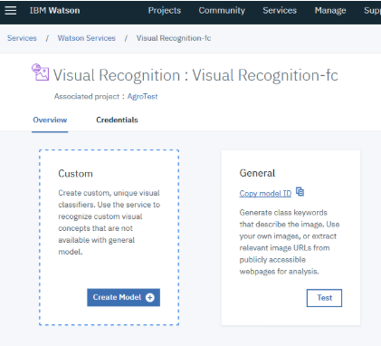

Fig. Different Options available in Visual Recognition

When we click Test on one of the models, the front page of that model opens. There we can find all of the information about the model such as how many data sets of pictures we have and how many pictures we uploaded.[4]
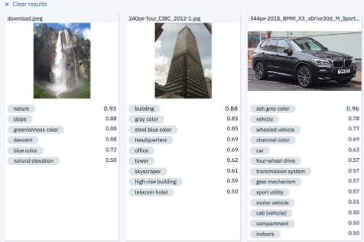
Fig. Different Pictures with there information they contain

When we click Implementation, we get code to call this model from code. There we can get codes the languages for Java, Python, Node, and Swift which we can use for our personal use.
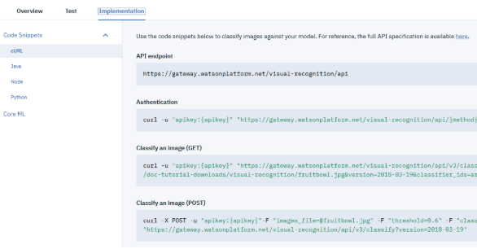
Fig. Different implementation codes are available for different languages
TRAINING
Before we go further we want that our system correctly predict the object. For that we have to train it with more and more images that are positive as well as negative. i.e. Positive images are the images which are in our favour, and negative images are the images which are not in our favour. So, we provide the system with both type of images.
COLLABORATION OF CAMERA AND IBM
After the training is completed we link our system with the IBM cloud so that with each image we take with our camera, system stores it in its cloud and improve with each process and task.
Now, as our tasks as
- Capturing images with camera
- Sending it to the IBM Cloud
- Analyse the properties of the image with training
But we have to perform a task depending upon the properties of the image. i.e. Classify the objects according to its type. So, to do that, we require a robotic arm. This will put the objects of the same type in a box or a part of the area.
ROBOTIC ARM
It usually consists of 3 sections, MATLAB based GUI, Arduino controller and robot arm.
A. Graphical User Interface
In the MATLAB based GUI with kinematics algorithm on the backend is implemented that provides friendly environment to control the robotic arm remotely.

B. Controller Unit
The microcontroller section will take the input of joint angles of robotic arm serially from MATLAB and actuates the motors at each joint to position it at the desired location in space. Also it collects information about the actual rotation of each joint of the robotic arm through accelerometers and helps in achieving the desired target. The ATmega2560 Arduino is generally used for communication purpose.
C. Robot Arm
The robot arm section mainly consists of shoulder, elbow, wrist and gripper joints interconnected by links. Each joint is equipped with a DC motor which helps in desired movement of the arm. The microcontroller output through a driver circuit will drive the motors to achieve desired task.[5]
To perform the task the training data are gathered initially. When enough training data are collected, they are fed as input to the IBM Cloud to train it. Once trained, the data will be tested by feeding a set of inputs that are different from the inputs of the training data. The outputs of the IBM Watson Visual Recognition are compared to what the actual outputs should be, hence calculating the errors.[6]
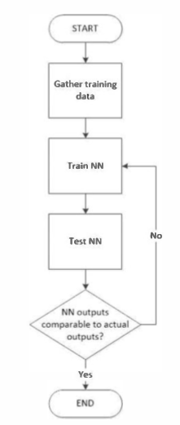
Fig. Process Flow of Error Calculation
Collection of Training Data
The figure below shows the robotic arm and the location of each joint of the robotic arm.
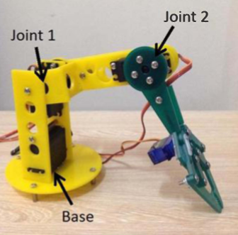
Fig. Robotic Arm Image
Joint 1 can move from -25⁰to 25⁰ with respect to the horizontal. Whereas joint 2 can move within -70⁰ to 130⁰. Whereas the base rotates from 0⁰ to 180⁰.
The coverage distance of the robotic arm is 21cm to the left, right and the front. So, the total region in which the robot can pick and drop any object is 882 cm². [7]
Training Process
Through IBM Watson Visual Recognition, the system will be trained by feeding the inputs (including object's coordinates) and the desired outputs (joint and base angles).
Testing Process
The testing include as
- Capturing the image with the camera
- Sending the image to the IBM Cloud for storage and training
- Analysing the information and properties of the image
- Setting up the robotic arm for the object
- Robotic arm perform its task i.e. lift the object
- After lifting the object, put it at its desired place.
- After dropping the object, arm return to its original position means at its zero coordinates.
Once these steps are completed camera look for another image. And the above steps go in loop till no more classifying image or the robot is not ordered to stop.

CONCLUSION
The designed robot was able to learn the relationship between the input through the camera and calculating the coordinates to manipulate the objects. However there are some input images that the IBM Visual Recognition cannot predict the output that where to put it means it is difficult for it to predict the output. This can be improved by adding more training images to the system. One should provide with more and more negative images so the system can calculate the wrong patterns in the images compared to the correct image. Such can also improve the speed of calculation of the output.
Future research about the application of the designed robot can be in the path of more advancement to the robot which may include the zones of defence i.e. the robot can be trained to find the type of bombs, or which path is dangers to go on for army persons.
We can also use this application in classes and office. The application will automatically mark the attendance of the students by clicking images at regular intervals and find out the common students in most of the images. Which will directly save the time and cost. Hence less human involvement and intervention will be needed to control and handle the application and the robot.
ACKNOWLEDGEMENTS
I am extremely thankful to my teacher Dr. Manoj Singh Adhikari and my classmates for their invaluable suggestions towards the making and improvement of the paper.
REFERANCES
- A Method of Recognizing Objects Specified by Color and Shape in Autonomous ROBOT by Yongxia Li, Zhanying Feng, Hong Sheng College of Automation Beijing Union University Beijing.
- https://www.creativelive.com/photography-guides/how-does-a-camera-work
- https://developer.ibm.com/articles/introduction-watson-visual-recognition
- https://cloud.ibm.com/catalog?search=label%3Alite
- Teaching and Learning Robotic Arm Model by Kadirimangalam Jahnavi and Sivraj P. Department of Electrical and Electronics Engineering, Amrita School of Engineering, Coimbatore, Amrita Vishwa Vidyapeetham, Amrita University India
- Object Locator and Collector Robotic Arm Using Artificial Neural Networl(s Ana Riza F. Quiros, Alexander C. Abad, Elmer P. Dadios Gokongwei College of Engineering De La Salle University Manila, Philippines
- https://youtu.be/YrChpyGrj1g

